**AI-POWERED RECRUITMENT SCREENING AND MANAGEMENT CHATBOT**

**BY**

**PEACE AJAYI**

**MATRIC NO: 2020/CP/CSC/00**

# ABSTARCT

This study explores the development and implementation of an AI-powered recruitment screening and management chatbot designed to improve the efficiency, objectivity, and fairness of the current hiring processes. Various recruitment methods, which rely heavily on manual resume screening by humans, are often time-consuming, inconsistent, and prone to biases. To address such challenges, this project used fine tuned Artificial Intelligence model deep-seek to automate the initial stages of candidate evaluation.

The system, RecruitAI, enables HR personnel to define job-specific criteria and upload multiple CVs for automated analysis. The system extracts key information from resumes, compares it against predefined criteria, and generates a summary along with a qualified or not qualified decision. This approach not only reduces the workload for recruiters but also ensures a standard and unbiased candidate assessments.

The study adopts the Agile methodology for system development, focusing on iterative design, testing, and validation. Key functionalities include real-time chatbot interaction, multi-CV processing, and AI-driven resume parsing. The system was tested using real-world recruitment scenarios, demonstrating its ability to accurately evaluate candidates based on qualifications and experience.

Findings highlight the chatbot's potential to streamline recruitment workflows, improve decision-making, and inclusivity by minimizing human biases. However some limitations was noticed such as language constraints and reliance on external AI services. Recommendations for future research include integrating machine learning for continuous improvement, expanding language support.

This work contributes to the growing body of research on AI in human resource management, offering a practical solution for organizations seeking to modernize their recruitment processes while adhering to ethical and legal standards.

# CHAPTER ONE

# INTRODUCTION

## 1.1 Background of study

Recruitment is a fundamental process in human resource management, as acquiring the right talent is crucial for organizational success. Traditional recruitment methods, which involve manually reviewing resumes, conducting interviews, and assessing candidates, are often time-consuming, inefficient, and prone to human biases (Dixit et al., 2022). With the increasing competition in the job market, organizations must adopt innovative strategies to attract, evaluate, and retain exceptional talent.

Artificial Intelligence (AI) has transformed several industries, including recruitment, by automating repetitive processes, enhancing decision-making, and reducing bias. AI-powered recruitment tools, particularly chatbots, have emerged as effective solutions to streamline hiring by automating tasks such as resume screening, candidate engagement, and interview scheduling. According to Albassam (2023), AI-driven strategies such as predictive analytics, resume screening, and chatbot interactions improve recruitment efficiency, reduce costs, and enhance the quality of hires.

This project focuses on developing an **AI-powered recruitment screening and management chatbot** designed to automate the initial screening phase. The chatbot will enable recruiters to select predefined criteria, accept CV uploads, and use Natural Language Processing (NLP) to analyze candidates’ information. Based on the selected criteria, the chatbot will generate a summary of the applicant’s qualifications and determine whether they meet the job requirements. Existing AI-based recruitment tools such as HireVue and Pymetrics, emphasizes on video interviews and behavioral assessments, this system will integrate AI-driven resume parsing and automated decision-making, ensuring a fair and transparent approach tailored to organizational needs.

The use of AI in recruitment offers several advantages. It can process large volumes of applications quickly, improving the speed and efficiency of hiring. AI algorithms can also enhance objectivity by evaluating candidates solely based on relevant qualifications and experience, reducing potential biases (Dixit et al., 2022). AI-powered chatbots facilitate candidate engagement by providing instant feedback, making the application process more interactive and user-friendly.

Despite these benefits, AI-based recruitment strategies present challenges, including algorithmic bias and ethical concerns. Albassam (2023) highlights that while AI enhances efficiency, organizations must ensure that their recruitment models are transparent, unbiased, and aligned with legal and ethical standards. This project aims to bridge these gaps by offering an AI-powered chatbot that balances automation with fairness, ensuring an inclusive and effective recruitment process.

By integrating AI into recruitment screening, this project seeks to revolutionize how organizations assess job applicants. Through automated CV analysis, customizable selection criteria, and instant candidate evaluation, the proposed system will not only enhance hiring efficiency but also contribute to a more standardized and fair recruitment process.

## 1.2 Statement of problem

It has been noted that traditional recruitment processes heavily rely on manual resume screening, which is time-consuming, inconsistent, and prone to human biases. Human resource personnel frequently encounter several challenges throughout the hiring process, which includes how to filter unqualified candidates and whilst ensuring consistent evaluations across different hiring managers. This not only slows down the recruitment process but also increases the chances of overlooking suitable talent. As organizations strive to balance speed and quality in hiring, the need for intelligent solutions becomes apparent. Integrating AI tools into recruitment workflows provides a path toward addressing these issues by automating repetitive tasks and reducing subjective decision-making (Yanamala, 2021). To address these inefficiencies, many companies outsource recruitment tasks to AI-powered hiring platforms such as HireVue and Pymetrics, which focus on video interviews and behavioral assessments (Haley, 2023). While these systems help streamline some aspects of recruitment, they do not fully eliminate the need for manual CV screening or provide a customizable, transparent, and unbiased selection process for organizations. Moreover, concerns about algorithmic bias persist, as AI-driven hiring tools may unconsciously reinforce prejudiced selection patterns based on factors like language and demography, leading to unintended discrimination (Haley, 2023).

Also organizations using third-party hiring platforms may face challenges regarding data privacy and security, as candidates’ personal information is stored and processed externally. Without robust encryption measures and regulatory oversight, sensitive applicant data may be vulnerable to unauthorized access or misuse.

## 1.3 Aim and Objectives

**Aim**: To develop an AI-powered recruitment chatbot that automates CV screening, evaluates applicants based on predefined job criteria, and provides instant feedback on candidate suitability.

**Objectives:**

1. Develop a chatbot interface that allows HR personnel to set screening criteria and upload multiple CVs for evaluation.
2. Implement natural language processing (NLP) to extract key information from resumes, including skills, education, and experience.
3. Design an AI-based evaluation system that compares extracted CV data against the selected criteria and determines whether a candidate passes or fails.

## 1.4 Significance of the Study

The significance of this study lies in its potential to **enhance efficiency, objectivity, and accuracy in the recruitment process** through AI-driven automation. Traditional recruitment methods often require HR personnel to manually screen large volumes of CVs, which is not only time-consuming but also prone to inconsistencies and biases. By automating this initial screening phase, the proposed AI-powered chatbot will **significantly reduce the time spent on resume evaluation**, allowing HR teams to focus on more strategic aspects of talent acquisition, such as interviews and candidate engagement. **AI-driven decision-making will improve the objectivity and fairness of candidate evaluations**, reducing the likelihood of unconscious bias influencing hiring decisions. Unlike human recruiters who may unintentionally prioritize candidates based on personal preferences or subjective interpretations, the AI chatbot will apply **consistent evaluation criteria**, ensuring a **standardized and unbiased selection process**. This will help organizations in fostering **a more diverse and inclusive workforce** by making hiring decisions based on qualifications and experience rather than implicit biases.

This system will be particularly beneficial for organizations that receive **large volumes of applications** and struggle to efficiently manage recruitment pipelines. By **automating CV analysis and candidate shortlisting**, companies can process applications more effectively and make data-driven hiring decisions, ultimately improving the overall **accuracy and efficiency of talent acquisition**. The use of AI in this context not only **optimizes recruitment workflows** but also **enhances the candidate experience**, providing timely and transparent feedback on their application status.

## 1.5 Scope of study

This study focuses on developing an AI-powered recruitment chatbot that **facilitates the initial screening process** in hiring. The system will enable **HR personnel to define job criteria at the start of each conversation**, ensuring that applicants are evaluated based on **predefined qualifications, skills, and experience** relevant to the role. Unlike traditional recruitment platforms that rely on manual screening, this chatbot will **automatically extract key information from submitted CVs** and assess their relevance to the job requirements. To ensure accessibility and usability, the chatbot will support **commonly used document formats such as PDF and DOCX**, allowing applicants to upload their resumes with ease. Once a CV is received, the system will **analyze its content using natural language processing techniques**, extract relevant details, and compare them against the predefined job criteria. Based on this analysis, the chatbot will generate a **summary of each applicant’s qualifications and a pass/fail decision**, providing recruiters with an efficient way to identify the most suitable candidates.

The chatbot will also support **multiple CV submissions within a single chat session**, enabling recruiters to evaluate several candidates at once without having to restart the process for each applicant. However, the scope of this system will remain **focused on text-based analysis**, meaning it will not incorporate **deep learning models for personality assessments or behavioral evaluations**, as seen in tools like HireVue and Pymetrics. Instead, the emphasis will be on **objective, transparent, and data-driven recruitment processes**, ensuring that hiring decisions are based solely on qualifications and job-related criteria.

## 1.6 Organization of work

This project is structured as follows:

1. Chapter One: Introduction, including background, problem statement, objectives, significance, scope, and organization of the study.
2. Chapter Two: Literature review covering existing recruitment systems, AI-powered chatbots, and related studies.
3. Chapter Three: System analysis and design, including an overview of the current recruitment process, limitations, and proposed system architecture.
4. Chapter Four: Implementation and testing of the chatbot, detailing algorithms, technology stack, and results.
5. Chapter Five: Conclusion and recommendations for future improvements

## 1.7 Definition of terms

1. **Artificial Intelligence (AI)**: The simulation of human intelligence in machines to perform tasks such as learning and decision-making.
2. **Chatbot**: An AI-powered program that interacts with users in natural language.
3. **Natural Language Processing (NLP)**: A field of AI that enables computers to understand and interpret human language.
4. **Recruitment Screening**: The process of evaluating job applicants to determine their suitability for a position.
5. **CV (Curriculum Vitae)**: A document that summarizes an individual's qualifications, work experience, and skills.
6. **Criteria Selection**: A set of predefined conditions used to filter job applicants.

CHAPTER TWO

LITERATURE REVIEW

2.1 Theoretical Framework

### 2.1.1 Artificial Intelligence in Recruitment

Artificial Intelligence (AI) is massively changing recruitment by automating various stages of the hiring process, improving efficiency, reducing biases, and enhancing candidate experience. Traditional recruitment methods, which rely heavily on manual screening of resumes and subjective decision-making, are often time-consuming and prone to inconsistencies. AI-driven recruitment systems address these challenges by leveraging automation, data analysis, and Natural Language Processing (NLP) to streamline hiring workflows.

One of the most important AI applications in recruitment is automated CV screening, where AI algorithms scan and analyze resumes, extracting key information such as qualifications, skills, work experience, and certifications. Unlike the traditional keyword-based searches, AI-powered screening systems use machine learning and NLP to understand the context of resumes, allowing for more accurate candidate matching. Systems like HireVue and Pymetrics incorporate AI to evaluate candidates' qualifications and potential fit for job roles, reducing the workload for HR professionals (Haley, 2023).

Another advancement is chatbot-driven interviews, where AI-powered chatbots interact with candidates to assess their suitability for a job. These chatbots conduct preliminary interviews by asking relevant questions, analyzing responses, and evaluating soft skills. By automating these early-stage interactions, companies can efficiently filter large applicant pools and ensure that only the most qualified candidates proceed to the next stages of hiring.

AI also plays a crucial role in decision-making by providing data-driven insights for recruiters. AI-powered recruitment systems use predictive analytics to assess a candidate's likelihood of success in a given role based on historical hiring data, skill assessments, and behavioral analysis. This aligns with research by Alrakhawi et al. (2024), who emphasize that AI-driven recruitment enhances accuracy and objectivity in candidate selection while reducing human biases in hiring decisions. Their study highlights how AI transforms Human Resource Management (HRM) beyond just recruitment, supporting more strategic decision-making in workforce planning and performance evaluation.

Despite its benefits, AI-driven recruitment is not without challenges. Algorithmic bias, lack of transparency, and ethical concerns regarding data privacy remain critical issues. AI models can inadvertently reinforce biases present in historical hiring data, leading to unfair candidate evaluations (Dixit et al., 2022). To mitigate these risks, organizations must ensure that AI recruitment tools are regularly audited and comply with ethical hiring standards.

Concluding, I will say AI is transforming recruitment processes by enhancing efficiency, objectivity, and decision-making in talent acquisition. As AI adoption in HR continues to grow, integrating fairness, transparency, and ethical considerations will be crucial in ensuring responsible and effective AI-driven hiring practices.

### 2.1.2 Machine Learning and Natural Language Processing (NLP) in Resume

### Screening

The application of Machine Learning (ML) and Natural Language Processing (NLP) in resume screening has improved the hiring process by automating candidate evaluation, reducing bias, and improving efficiency. Traditional resume screening methods require significant human effort, making them time-consuming and often prone to subjectivity. By leveraging on NLP and ML, organizations can analyze and classify resumes more effectively, ensuring that only the most relevant candidates are shortlisted.

ML and NLP technologies enable resume screening systems to process unstructured textual data, extract relevant information, and match candidates to job roles based on predefined criteria. NLP techniques, such as Named Entity Recognition (NER), Part-of-Speech (POS) tagging, and semantic analysis, help parse resumes and identify critical details like qualifications, skills, work experience, and certifications (Sinha et al., 2021). ML algorithms further enhance this process by learning patterns from previous hiring decisions, thereby improving the accuracy of candidate selection over time. Ali et al. (2022) conducted an experimental study using NLP and ML-based resume classification systems to categorize job applications based on job roles. Their research evaluated nine ML classification models, including Support Vector Machines (SVM), Naïve Bayes, K-Nearest Neighbors (KNN), and Logistic Regression (LR). The study found that SVM classifiers achieved over 96% accuracy when using the Term-Frequency Inverse-Document-Frequency (TF-IDF) feature representation scheme. This high accuracy demonstrates the effectiveness of ML-driven resume screening in automating and optimizing candidate evaluation. Saatci et al. (2024) proposed an NLP-based system that uses Jaccard Similarity to compare candidate resumes with predefined competency sets. Their research highlights the efficiency of NLP in ranking applicants based on required skill sets, reducing bias by focusing on competencies rather than personal identifiers. The integration of such systems with platforms like LinkedIn further enhances their usability by allowing seamless resume imports and automated analysis.

Several theories underpin the use of AI in resume screening and HR decision-making. One such framework is Information Retrieval Theory, which focuses on how textual data can be processed and analyzed to retrieve the most relevant information. In resume screening, this theory is applied through NLP techniques such as TF-IDF and semantic search, which help in ranking candidates based on relevance to job descriptions (Sinha et al., 2021). Another relevant perspective is Human Capital Theory, which suggests that an individual’s education, skills, and experience contribute to their value in the labor market. AI-driven resume screening aligns with this theory by quantifying candidates' competencies and matching them to job roles based on their qualifications and experiences, ensuring an objective evaluation process (Ali et al., 2022). Algorithmic Decision Theory plays a crucial role in AI-driven recruitment. This theory examines how computational models can support human decision-making by optimizing choices based on data patterns. In resume screening, ML algorithms help HR professionals make data-driven hiring decisions, reducing human bias while improving efficiency (Saatci et al., 2024).

Despite its advantages, AI-driven resume screening is not without challenges. One major concern is algorithmic bias, where AI models may inherit biases from historical hiring data, leading to unfair candidate evaluations. Ensuring fairness requires continuous auditing of AI models and using explainable AI techniques to enhance transparency in hiring decisions (Ali et al., 2022). Additionally, data privacy concerns arise when handling sensitive candidate information, necessitating compliance with regulations such as the General Data Protection Regulation (GDPR). ML and NLP technologies have significantly enhanced the efficiency and accuracy of resume screening by automating information extraction, classification, and ranking of candidates. By leveraging advanced text-processing techniques and predictive analytics, AI-driven systems can help organizations streamline hiring while minimizing bias. However, ethical considerations such as data privacy and algorithmic fairness must be addressed to ensure the responsible use of AI in recruitment. As AI continues to evolve, HR professionals must strike a balance between automation and human oversight to achieve the best recruitment outcomes.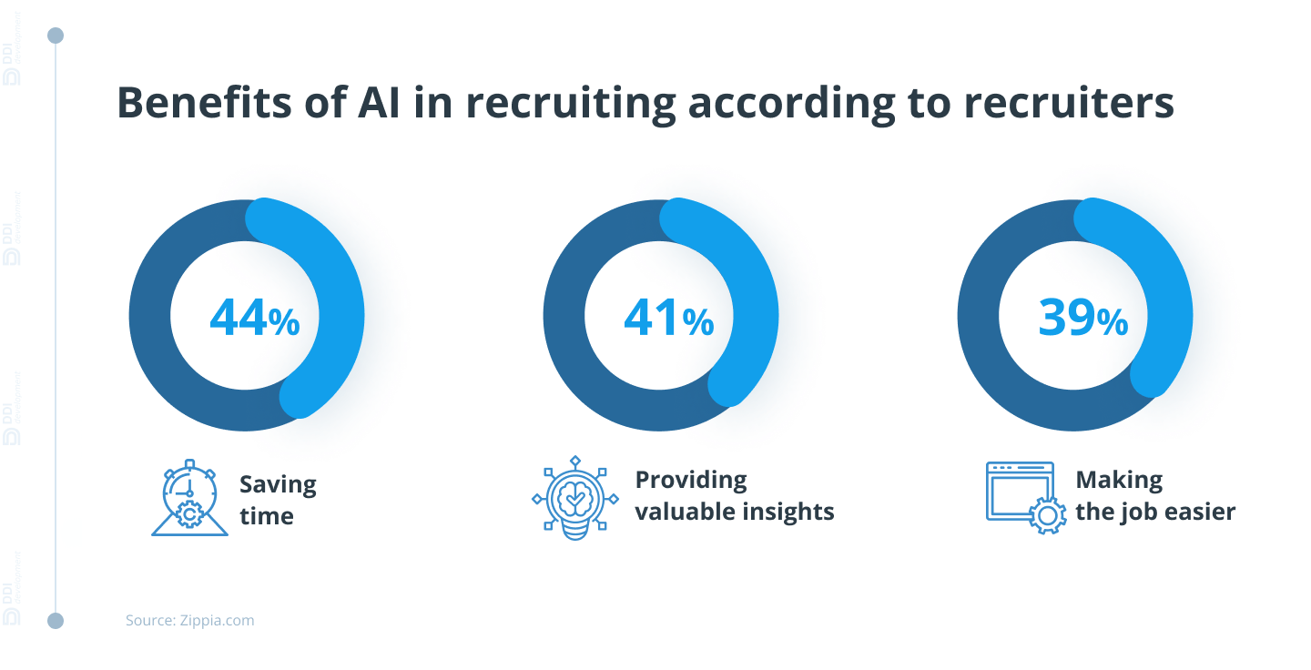

*Figure 2.1 Benefits of AI in recruiting according to recruiters(DDI Development 2023)*

### 2.1.3 Decision-Making Theories in Recruitment

Decision-making in recruitment is a critical aspect of human resource management, determining the effectiveness of talent acquisition strategies. Traditional decision-making models, such as the **Rational Decision-Making Model** and **Bounded Rationality**, have long guided HR professionals in selecting the most suitable candidates. However, the integration of AI-driven algorithms in recruitment is reshaping these decision-making processes, improving efficiency, reducing biases, and enhancing objectivity.

The **Rational Decision-Making Model** assumes that recruiters systematically analyze all available information before making the optimal hiring decision. AI aligns with this model by using structured data, predefined criteria, and statistical analysis to evaluate candidates objectively. Advanced algorithms assess resumes, conduct automated interviews, and rank applicants based on job-related competencies, ensuring a more data-driven selection process. In contrast, **Bounded Rationality**, introduced by Herbert Simon, suggests that human decision-making is limited by cognitive constraints, time, and available information. AI mitigates these limitations by processing vast amounts of data quickly, identifying patterns, and recommending the best candidates based on measurable factors.

While AI enhances objectivity in recruitment, it also raises concerns about **applicants' affective responses to AI-driven hiring processes**. According to Köchling, Wehner, and Warkocz (2023), AI-supported selection processes can negatively impact candidates' perception of organizational attractiveness. Their study highlights that AI-driven telephone and video interviews reduce candidates' opportunity to perform and increase **emotional creepiness**, leading to potential dissatisfaction. However, AI preselection in the early stages does not generate such adverse responses, indicating that AI’s role in recruitment should be strategically positioned to balance efficiency and candidate experience.

Comparing **human vs. AI-driven decision-making in recruitment**, human recruiters bring emotional intelligence, adaptability, and context-awareness to hiring decisions, which AI lacks. However, humans are also prone to biases, inconsistent evaluations, and fatigue-induced errors. AI, on the other hand, ensures **consistency, scalability, and data-driven accuracy**, but it may struggle with nuanced judgments such as cultural fit and soft skills assessment. Thus, an **AI-human hybrid approach**—where AI handles initial screenings and structured evaluations while humans oversee final decisions can optimize recruitment outcomes, maintaining both efficiency and fairness.

### 2.1.4 Ethical and Legal Considerations in AI-Based Hiring

The growing reliance on AI-driven personnel selection tools has sparked significant ethical and legal concerns regarding **bias, transparency, data privacy, and job relevance**. While AI improves efficiency, reduces costs, and enhances applicant engagement, its adoption in hiring raises questions about fairness, reliability, and compliance with legal standards (Ippins et al., 2021).

One of the primary ethical challenges is **algorithmic bias**, where AI systems may unintentionally discriminate against candidates due to biased training data. AI-powered hiring tools often pull data from **resumes, test responses, and social media**, potentially reinforcing past biases if not carefully designed (Ippins et al., 2021). Moreover, these tools may lack **conceptual relevance to the job**, meaning they do not always align with **job analysis** to ensure fair evaluation. This raises concerns about **validity and reliability**, questioning whether AI can consistently predict employee performance. Another ethical concern is **autonomy and transparency** in decision-making. AI systems typically operate as **black boxes**, making it difficult for candidates to understand how hiring decisions are made. According to Hunkenschroer and Kriebitz (2023), AI hiring should uphold **human rights principles**, including **nondiscrimination, privacy, and transparency**. Employers must ensure that AI recruitment tools are explainable and do not compromise candidates’ **autonomy** by making hiring decisions without human oversight. The legal landscape for AI-driven recruitment is evolving to address these concerns. In the European Union, the **General Data Protection Regulation (GDPR)** enforces strict guidelines on **data privacy**, ensuring that candidates are informed about how their personal information is collected and used. Under GDPR, candidates have the **right to explanation**, allowing them to request insights into AI-driven hiring decisions (Hunkenschroer & Kriebitz, 2023).

The **EU AI Act** classifies **AI-driven hiring as a high-risk application**, requiring organizations to implement transparency measures, **bias audits**, and risk assessments. Similar regulations exist in the U.S., where the **Equal Employment Opportunity Commission (EEOC)** mandates that AI hiring tools comply with **anti-discrimination laws**, ensuring fair treatment of candidates. Ippins et al. (2021) emphasize the importance of **extending professional standards** for employment testing to AI-based selection tools to enhance **accountability and ethical compliance**. To mitigate ethical and legal risks, organizations must implement **bias detection strategies, transparency measures, and regulatory compliance frameworks**. Key actions include:

1. Conducting **regular AI audits** to detect and correct biases.
2. Ensuring AI hiring tools align with **job analysis and performance prediction standards** (Ippins et al., 2021).
3. Providing **candidates with clear explanations** about how AI systems evaluate their applications (Hunkenschroer & Kriebitz, 2023).
4. Adhering to legal frameworks such as GDPR, the EU AI Act, and EEOC regulations.

While AI enhances recruitment efficiency, its ethical and legal implications must be **carefully managed** to prevent discrimination, uphold **human rights principles**, and ensure **compliance with evolving regulations**. Organizations must adopt a **responsible AI strategy**, integrating human oversight and transparent decision-making to foster fair and ethical hiring practices.

2.2 Review of related Works

Artificial Intelligence (AI) has significantly transformed recruitment processes, improving efficiency and reducing human biases in hiring decisions. Several studies have explored the impact of AI in recruitment, emphasizing both its benefits and challenges.

One widely discussed AI-powered hiring tool is HireVue, Haley (2023)an AI-driven video interviewing platform that uses facial analysis, speech recognition, and machine learning to assess candidates’ verbal and non-verbal cues. Proponents argue that HireVue enhances hiring efficiency by standardizing evaluations and reducing human bias. Concerns have been raised about the ethical implications of AI-driven facial analysis, particularly regarding its accuracy across different demographic groups. Critics argue that facial recognition technology may disadvantage candidates from underrepresented backgrounds due to algorithmic biases. Some researchers question the scientific validity of correlating facial expressions with job performance, emphasizing the need for more transparent evaluation criteria. Regulatory bodies are increasingly addressing the ethical and legal challenges of AI in hiring. Haley (2023) discusses the European Union's proposed artificial intelligence regulation on recruiting and hiring processes, which seeks to establish clear guidelines for AI-based hiring tools. The regulation categorizes AI-driven recruitment systems as "high-risk" applications, requiring companies to demonstrate transparency, fairness, and compliance with non-discrimination laws. If implemented, these regulations could reshape how AI is used in recruitment, pushing organizations toward greater accountability and responsible AI adoption.

Dixit et al. (2022) explore the role of AI-powered recruitment in streamlining talent acquisition by automating repetitive and time-consuming tasks such as resume screening, candidate shortlisting, and initial engagement through intelligent chatbots. Their study emphasizes how AI-driven systems enhance the hiring process by reducing human biases and increasing efficiency in candidate evaluation. Beyond traditional resume-based assessments, AI algorithms analyze candidates’ skills, experience, and behavioral traits using natural language processing and machine learning techniques. The study further highlights how AI-driven recruitment platforms can assess candidate responses, predict job suitability, and personalize hiring recommendations based on historical data and organizational requirements. This approach not only accelerates the recruitment cycle but also improves the overall candidate experience by providing timely feedback and enhancing engagement throughout the process.

Albassam (2023) further expands on AI-based recruitment strategies, identifying advanced tools such as predictive analytics, gamification, and virtual reality (VR) assessments, which have revolutionized the hiring landscape. Predictive analytics enables organizations to assess vast amounts of applicant data to forecast job performance and cultural fit, leading to data-driven hiring decisions. Gamification techniques, such as AI-powered skill assessments and behavioral simulations, enhance candidate engagement while providing recruiters with deeper insights into cognitive abilities and problem-solving skills. Additionally, VR assessments offer immersive experiences that test candidates in real-world job scenarios, improving the accuracy of role suitability evaluations. Despite these advancements, Albassam (2023) highlights significant challenges associated with AI-driven recruitment. One of the primary concerns is algorithmic bias, where historical hiring data used to train AI models can reinforce existing biases, potentially leading to unfair candidate evaluations. Ethical concerns also arise in terms of data privacy, as AI systems collect and analyze extensive personal and professional information, raising questions about consent and security. Furthermore, there is an ongoing debate about the level of human oversight required in AI-driven recruitment to ensure fairness and accountability.

Hunkenschroer and Kriebitz (2023) analyze AI recruitment through a human rights perspective, stressing the importance of transparency, nondiscrimination, and privacy in AI-powered hiring practices. They argue that while AI can enhance efficiency and objectivity in recruitment, it also presents risks related to the lack of explainability in decision-making processes. Many AI algorithms operate as "black boxes," making it difficult for candidates and recruiters to understand how hiring decisions are made. This lack of transparency can lead to distrust in AI-based recruitment systems, particularly if applicants feel they are being unfairly assessed. A key gap in current AI recruitment research and implementation is the lack of standardized regulatory frameworks governing AI ethics in hiring. While various organizations adopt AI tools, there is no universally accepted guideline ensuring responsible AI usage, leaving room for discrepancies in how fairness, privacy, and accountability are maintained. Moreover, most AI recruitment models prioritize efficiency and cost reduction over candidate experience and long-term employee success, highlighting a need for further studies on the holistic impact of AI in talent acquisition. Addressing these gaps requires a balanced approach that integrates AI-driven efficiency with human oversight, ethical AI frameworks, and ongoing algorithmic audits to ensure fairness and transparency in hiring practices.

Alrakhawi et al. (2024) provide a broader perspective on AI’s role in Human Resource Management (HRM), emphasizing its transformative potential in strategic decision-making, bias reduction, and performance management. AI-driven HRM systems leverage predictive analytics to optimize workforce planning, identify skill gaps, and enhance succession planning. These systems allow HR professionals to analyze large volumes of employee data to predict attrition rates, recommend personalized training programs, and align talent with organizational goals. Moreover, AI tools can improve performance management by offering continuous feedback mechanisms, automating performance appraisals, and identifying key performance indicators (KPIs) with greater precision. One of the major achievements of AI in HRM, as highlighted by Alrakhawi et al. (2024), is its ability to enhance fairness in recruitment and employee evaluations. By automating processes such as resume screening and candidate ranking, AI can minimize human biases that often affect hiring decisions. However, while AI has the potential to reduce bias, it can also unintentionally reinforce discrimination if not carefully monitored. Biased training datasets or flawed algorithmic assumptions can lead to unfair outcomes, making it crucial for HR professionals to ensure responsible AI implementation.

Tippins et al. (2021) further explore the complexities of AI-based personnel selection, focusing on concerns regarding the validity, reliability, and job relevance of AI-driven assessment tools. While AI has improved efficiency in candidate evaluation, questions remain about whether these tools accurately measure job-related competencies. Many AI-powered assessments rely on behavioral data, facial recognition, and psychometric testing, but the effectiveness of such methods varies across industries and job roles. If AI models are not rigorously validated, there is a risk that hiring decisions may be based on arbitrary or misleading indicators rather than genuine job qualifications.He argues that existing employment testing standards may not fully address the complexities of AI-driven selection processes. Traditional employment assessments are subject to professional guidelines that ensure fairness, validity, and reliability, but AI-based tools often operate outside these established frameworks. This creates a gap in regulatory oversight, raising concerns about accountability when AI-based hiring decisions lead to adverse outcomes. To address this challenge, HR professionals and policymakers must work together to establish updated standards that govern the ethical use of AI in hiring and personnel management.

Despite these challenges, both Alrakhawi et al. (2024) and Tippins et al. (2021) agree that AI’s role in HRM will continue to expand. The key to maximizing its benefits lies in adopting a balanced approach that integrates AI-driven efficiency with human judgment. Organizations must prioritize transparency, continuously audit AI models for bias, and ensure that AI tools align with legal and ethical employment practices. By doing so, AI can serve as a powerful complement to human decision-making rather than a replacement, ultimately enhancing HRM effectiveness while maintaining fairness and accountability.

The effectiveness of AI-powered chatbots in recruitment is examined by Tuffaha et al. (2022), particularly in the Indian market. Their study reveals that chatbots facilitate efficient candidate interactions but have limitations in hiring mid- and senior-level positions. Ore & Sposato (2021) further investigate AI’s opportunities and risks in recruitment, finding that while automation improves routine task efficiency, recruiters remain apprehensive about job displacement due to AI adoption. Fraij & László (2021) provide a systematic review of AI’s impact on recruitment, affirming that AI-driven automation significantly reduces repetitive administrative tasks, allowing HR professionals to focus on strategic functions such as talent development, workforce planning, and employee engagement. They highlight that AI streamlines recruitment through automated resume screening, interview scheduling, and chatbot-based candidate interactions, they stress the importance of unbiased AI implementation, noting that AI models trained on historical hiring data may reinforce existing biases, leading to potential discrimination if not carefully monitored. To mitigate these risks, they recommend regular audits of AI algorithms, diverse training datasets, and human oversight in final hiring decisions.

Sinha et al. (2021) explore AI-powered resume screening techniques, demonstrating how Natural Language Processing (NLP) and machine learning improve the accuracy and efficiency of extracting candidate information from unstructured resumes. These technologies allow AI systems to analyze resumes beyond keyword matching, enabling a deeper understanding of candidates’ skills, experiences, and qualifications. While this enhances the precision of candidate shortlisting, challenges remain regarding data privacy, transparency, and the potential exclusion of non-traditional applicants whose qualifications may not align perfectly with predefined AI criteria.

Overall, while AI continues to revolutionize recruitment by increasing efficiency and data-driven decision-making, challenges related to fairness, bias, and regulatory compliance remain. Moving forward, a hybrid approach that combines AI’s analytical power with human judgment may be the most effective strategy for ensuring ethical and effective hiring practices.

2.3 Summary of Reviewed Works and Research Gaps

|  |  |  |  |
| --- | --- | --- | --- |
| **Author(s) & Year** | **Title** | **Key Findings** | **Research Gaps** |
| Fraij & László (2021) | AI’s Impact on Recruitment: A Systematic Review | AI-driven automation reduces repetitive tasks, allowing HR professionals to focus on strategic functions. Highlights the need for unbiased AI implementation to ensure fairness in hiring. | Lack of standardized ethical guidelines and auditing mechanisms for AI-driven recruitment. Requires more research on mitigating bias and ensuring transparency. |
| Sinha et al. (2021) | AI-Powered Resume Screening Using NLP & Machine Learning | Demonstrates how AI improves accuracy and efficiency in extracting candidate details from unstructured resumes. NLP enhances screening speed and effectiveness. | Privacy concerns related to automated data extraction. Need for more explainable AI models to improve HR trust in automated decisions. |
| Ore & Sposato (2021) | AI Opportunities and Risks in Recruitment | AI automation improves efficiency in routine recruitment tasks. However, recruiters express concerns about job displacement due to AI adoption. | Further research needed on AI’s long-term impact on recruitment professionals' roles and potential employment shifts. |
| Tippins et al. (2021) | AI-Based Personnel Selection: Validity & Reliability Concerns | Raises concerns about the validity, reliability, and job relevance of AI-based hiring tools. Calls for extended professional standards in AI-driven employment testing. | Need for rigorous empirical testing to validate AI-driven selection tools. Calls for industry-wide standardization and ethical AI implementation. |
| Dixit et al. (2022) | AI-Powered Recruitment & Talent Acquisition | AI streamlines hiring by automating resume screening, shortlisting, and initial candidate engagement via chatbots. Enhances candidate evaluation beyond traditional resume-based assessments. | Potential biases in AI decision-making. Need for further studies on candidate experience and AI’s long-term impact on hiring diversity. |
| Tuffaha et al. (2022) | Effectiveness of AI-Powered Chatbots in Recruitment | Examines AI chatbot effectiveness in recruitment, particularly in the Indian market. Finds chatbots facilitate efficient candidate interactions but struggle with mid- and senior-level hiring. | More research needed on chatbot performance in higher-level recruitment and candidate perception of chatbot-led hiring processes. |
| Albassam (2023) | AI-Based Recruitment Strategies: Predictive Analytics & Gamification | Identifies AI tools such as predictive analytics, gamification, and virtual reality in recruitment. Highlights efficiency gains and cost reductions. | Ethical concerns regarding algorithmic bias and fairness. Need for legal frameworks to regulate AI’s role in hiring. |
| Hunkenschroer & Kriebitz (2023) | AI-Driven Recruitment & Human Rights | Examines AI hiring from a human rights perspective. Emphasizes the importance of transparency, nondiscrimination, and privacy considerations. | Calls for stronger governance policies to protect candidates. Further exploration needed on bias mitigation techniques. |
| Haley (2023) | The European Union’s Proposed AI Regulation on Recruiting & Hiring Processes | Discusses the EU’s regulatory approach to AI in hiring, ensuring compliance with ethical standards and data privacy. | Limited empirical studies on how AI regulations impact recruitment efficiency. Need for comparative analysis across different regulatory frameworks. |
| Alrakhawi et al. (2024) | AI in Human Resource Management (HRM) | Explores AI’s role in strategic decision-making, bias reduction, and performance management. Stresses the need for HR professionals to adapt to AI-driven changes. | Calls for more case studies on AI’s long-term effectiveness in HR functions. Need for ethical frameworks to guide AI adoption. |

This table provides a clear overview of key insights and gaps in the reviewed works., highlighting areas where further exploration and development are needed to recruitment process using artificial intelligence.

# CHAPTER THREE

SYSTEM ANALYSIS, DESIGN AND METHODOLOGY

## 3.1 Analysis of the Existing System

The growing adoption of AI-powered recruitment screening has significantly transformed traditional hiring processes. HireVue, one of the most widely used AI-driven hiring platforms that leverages on machine learning and video analysis to streamline candidate evaluation. The system automates initial stages of recruitment, including resume screening and interviews, which reduces recruiter workload and enhances efficiency. A critical aspect of HireVue’s operation is its reliance on artificial intelligence to analyze both textual and visual data from candidates. The system follows a structured process where applicants first submit their resumes and then proceed to an AI-powered video interview. Unlike conventional methods, which require human recruiters to screen resumes and conduct interviews manually, HireVue uses natural language processing (NLP) and facial recognition technology to assess candidate responses. This process claims to eliminate subjectivity and enhance decision-making by ensuring every applicant is evaluated under uniform conditions. However, concerns have been raised regarding the potential for bias within AI models. Since AI systems are trained on historical hiring data, they may unintentionally reinforce existing prejudices in recruitment, potentially disadvantaging certain demographics, also critics argue that AI's ability to assess a candidate’s demeanor or enthusiasm may be influenced by non-performance-related factors, such as cultural differences or disabilities, leading to unfair evaluations. Moreover, the impersonal nature of AI-led interviews may create discomfort among candidates who prefer human interaction during the recruitment process.

* + 1. **Data Flow of the Existing System**

The data flow in HireVue follows a structured yet complex pipeline. Candidates begin by submitting their applications through an employer’s hiring portal, after which the system extracts relevant information from resumes using NLP algorithms. This stage is crucial in filtering out applications that do not match the job’s required skills or qualifications. Following resume screening, candidates participate in an asynchronous video interview, where they respond to prerecorded questions within a set time frame. The AI then analyzes these responses based on verbal content, tone, facial expressions, and even body language. While this approach introduces objectivity into candidate evaluation, it also raises concerns about the accuracy and ethical implications of AI-driven facial analysis. Once the AI completes its analysis, it generates a comprehensive report containing candidate scores, which are then reviewed by human recruiters. While this step ensures a degree of human oversight, recruiters primarily rely on AI-generated rankings when making decisions.

* + 1. **Advantages of the Existing System**

HireVue has introduced several efficiencies in recruitment, particularly in high-volume hiring processes where companies receive thousands of applications. By automating resume screening and video interviews, the system significantly reduces the time required for recruiters to shortlist candidates. This is particularly beneficial for organizations handling large-scale recruitment, as it allows them to assess multiple applicants simultaneously without compromising hiring speed.

Beyond speed, HireVue also contributes to standardizing candidate evaluations. Unlike traditional interviews, where human biases can influence decision-making, AI ensures that all candidates are assessed using the same criteria. This standardization helps organizations maintain a fair and structured recruitment process. Additionally, the system provides recruiters with data-driven insights, offering a more comprehensive view of candidate suitability beyond what is traditionally obtained through resumes alone, or candidates, the flexibility of completing interviews at their convenience is another advantage. Unlike live interviews, where scheduling conflicts can pose challenges, HireVue allows applicants to record their responses at any time within a given deadline. This accessibility benefits job seekers, especially those applying for international roles across different time zones. However, despite this flexibility, the lack of real-time human interaction in AI-led interviews can make the process feel impersonal, potentially affecting candidate engagement and perception of employer brand

* + 1. **Disadvantages of the Existing System**

Despite its advantages, HireVue has faced significant criticism over its limitations, particularly in the areas of bias, ethical concerns, and its effectiveness in evaluating candidates beyond surface-level traits. One of the primary concerns is the potential for AI bias, as the system learns from historical hiring data, which may contain underlying prejudices. If the training data reflects past hiring preferences that favored certain groups over others, the AI may inadvertently perpetuate these biases, leading to unfair hiring outcomes.

The reliance on facial recognition and emotion analysis introduces additional ethical dilemmas. Research has shown that facial recognition technology can exhibit biases based on race and gender, potentially misinterpreting expressions differently across diverse populations. This calls into question the fairness of assessments that rely on such technology. The European Union’s proposed AI regulations, as discussed by Haley (2023), highlight these ethical concerns and stress the need for greater transparency in AI-driven hiring. Organizations using AI-powered recruitment tools may soon be required to disclose how their algorithms function and ensure that AI assessments do not lead to discriminatory practices.

Another major limitation of HireVue is its suitability for evaluating mid-to-senior level candidates. While AI-driven screening works efficiently for entry-level and high-volume hiring, it may not be as effective in assessing leadership skills, problem-solving abilities, or industry-specific expertise. Senior roles often require complex decision-making and interpersonal skills that cannot be adequately captured through prerecorded video responses or keyword-based resume screening. This limitation forces companies to supplement AI evaluations with traditional interviews, reducing the overall efficiency AI aims to achieve. The system's reliance on technology can create accessibility issues for candidates. Job seekers who are unfamiliar with AI-driven assessments or lack the necessary digital resources may struggle to navigate the system, putting them at a disadvantage. In cases where candidates have limited internet access, poor video quality or disruptions during the interview process could negatively impact AI assessments, leading to inaccurate candidate evaluations

* 1. Analysis of the new system

The proposed AI-powered recruitment screening chatbot introduces a streamlined, automated approach to candidate evaluation. By leveraging Natural Language Processing (NLP) and machine learning, the chatbot extracts relevant information from CVs and evaluates applicants based on predefined criteria. This enhances the efficiency of the recruitment process by reducing the manual effort required for initial screening. The chatbot ensures consistency in decision-making, eliminating human biases that may arise in traditional resume reviews.

Unlike existing AI recruitment tools like HireVue, which rely on video interviews and facial recognition, the proposed chatbot focuses purely on text-based resume analysis. This makes it more accessible and inclusive, ensuring that candidates are assessed based on their qualifications rather than their video presence or verbal communication skills. The chatbot enables real-time human resource personnel engagement, providing immediate feedback on the application status of all candidates through a simple workflow, HR first selects the evaluation criteria from a predefined list once the chat begins. The HR then can uploads multiple CVs, which the chatbot will analyze each document individually, summarizing the key details relevant to the criteria selected before determining if the applicant "passes" or "fails". This approach provides a structured yet flexible screening process that adapts to various recruitment needs.

* + 1. **Justification of the New System**

The adoption of this AI-powered chatbot is justified by its ability to address key limitations of traditional and existing AI recruitment systems. It significantly reduces the workload on recruiters by automating repetitive tasks, allowing HR professionals to focus on higher-level decision-making. It also enhances **objectivity** by applying standardized criteria to every application, mitigating biases that often affect human-led screening.

**T**he chatbot promotes **scalability** by enabling recruiters to process a large volume of applications efficiently. Organizations with high applicant numbers, such as multinational companies or firms experiencing rapid growth, will benefit from the chatbot’s capability to handle multiple CVs in a single chat session. Also, the chatbot provides a **cost-effective** solution by eliminating the need for extensive AI-driven video interviews and complex infrastructure.

This system aligns with **ethical AI principles** by focusing on skills-based assessment rather than subjective factors. It complies with concerns raised in regulatory discussions, such as those in Haley (2023), regarding **AI bias, transparency, and fairness** in recruitment. By ensuring that hiring decisions are based purely on professional qualifications, the chatbot contributes to a more **inclusive hiring process**.

3.3 Methodology Adopted

For the development of the AI-powered recruitment chatbot, the Agile methodology will be adopted to ensure flexibility, iterative development, and continuous improvement throughout the project lifecycle.

1. Project Initiation: Define the project’s objectives, identify stakeholders, and assess feasibility to ensure alignment with organizational needs.
2. Planning and Requirements Gathering: Collect detailed requirements, establish the project scope, allocate resources, and set timelines and milestones.
3. System Design and Architecture: Design the chatbot’s architecture, user interface, and AI models for resume parsing and candidate evaluation.
4. Development (Agile Sprints): Develop the chatbot in iterative sprints, implementing features like resume parsing, candidate evaluation, and integration with HR systems.
5. Testing and Validation: Conduct comprehensive testing, including user, performance, and security testing, to ensure the chatbot functions as expected.
   1. High-Level Model of the New System

The high-level model of the proposed AI-powered recruitment screening chatbot outlines the key components and interactions within the system. The chatbot operates as an automated screening assistant, processing candidate resumes against predefined selection criteria. The architecture consists of multiple integrated modules that facilitate smooth interaction between the recruiter, applicants, and the AI system. The system architecture includes:

1. User Interaction Layer: The recruiter initializes the chat session by selecting specific criteria from a predefined list (e.g., years of experience, required skills, certifications). Applicants upload their CVs through the chatbot interface, the chatbot provides real-time responses, summarizing each CV and indicating whether the candidate "passes" or "fails" based on the selected criteria.
2. Processing Layer: Natural Language Processing (NLP) Module: Extracts key information from CVs, including education, work experience, skills, and achievements.
3. Criteria Matching Engine: Compares extracted details with the recruiter’s selected criteria.
4. Decision Logic Module: Evaluates whether the applicant meets the criteria and generates a summary along with a pass/fail decision.
5. Data Storage & Management: Stores uploaded CVs, extracted candidate details, and screening results for future reference, saves recruiter-selected criteria per session to maintain consistency across multiple CV evaluations.
6. Response & Feedback Mechanism: The chatbot generates a structured response summarizing the candidate's qualifications in relation to the criteria, It provides the final pass/fail decision instantly.

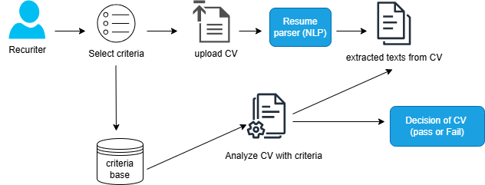

*Figure 3.1 High level model of the new system*

*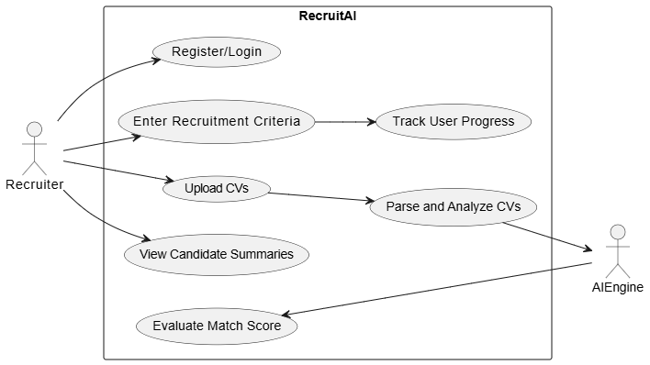*

*Figure 3.2 Use-case of the new system*

3.5 Specification

**3.5.1 Program Module Specification**

The AI-powered recruitment screening chatbot is structured into various program modules to ensure efficiency, scalability, and maintainability. These modules interact to process CVs based on predefined criteria and provide recruiters with a summarized evaluation. The main modules include:

1. **User Interface (UI) Module** : This module provides a web-based or chatbot interface for recruiters, it allows recruiters to select criteria and upload CVs, displays CV summaries and pass/fail results.
2. **Criteria Selection Module**: This module enables recruiters to define the required qualifications for the position and stores selected criteria for processing multiple CVs within the session.
3. **CV Processing Module**: This module handles document parsing using Natural Language Processing (NLP), extracts relevant details such as education, skills, and experience and structures extracted data for comparison with predefined criteria.
4. **Evaluation Module**: This modules compares extracted CV data with selected criteria, it applies machine learning-based matching algorithms and determines whether a candidate meets the requirements.
5. **Response Generation Module**: This module summarizes key details from the CV., provides a pass/fail decision based on the evaluation and sends the response back to the recruiter in a user-friendly format.
6. **Database Management Module**: This module stores recruiter-selected criteria and processed CV data. Maintains logs for future reference and compliance.

## 3.5.2 Database Development Tool and Design

The database for the AI-powered recruitment chatbot will be developed using MySQL due to its scalability, reliability, and support for structured queries. The system will interact with the database through Sequelize ORM for efficient querying and data management.

**Database Design**

The database consists of key tables to manage recruiters(users), CVs, criteria, and evaluation results:

This structured database design ensures efficient retrieval of data, maintains recruiter-specific evaluations, and supports scalability for handling large volumes of CVs.

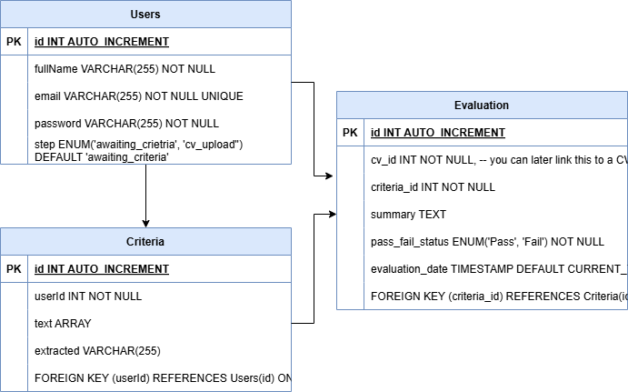

***Figure 3.3 Entity Relationship Diagram of the new system***

3.5.3 Input/output Design

The **AI-powered recruitment screening chatbot** is designed to efficiently collect, process, and present candidate information to recruiters.

#### ****Input:****

1. Selection of job-specific screening criteria (e.g., education level, skills, years of experience).
2. Upload of CV files in supported formats (PDF, DOCX).

#### ****Output:****

1. A structured summary of each CV, highlighting key details such as education, skills, and experience.
2. A **pass/fail** decision based on the selected criteria.
3. A list of qualified and unqualified candidates for further action.

The system ensures clarity and ease of use, enabling recruiters to make informed hiring decisions efficiently.

3.5.4 Data Dictionary

The data dictionary defines the structure of the database and the attributes of each entity involved in the system.

**User Table**

|  |  |  |
| --- | --- | --- |
| **Field Name** | **Data Type** | **Description** |
| id | INT (Primary Key) | Unique identifier for each recruiter. |
| fullName | VARCHAR(255) | Full name of the recruiter. |
| email | VARCHAR(255) | Email address used for login. |
| password | VARCHAR(255) | Password for login. |
| step | ENUM | Step to tell where user left off. |

**Criteria Table**

|  |  |  |
| --- | --- | --- |
| **Field Name** | **Data Type** | **Description** |
| id | INT (Primary Key) | Unique identifier for each criterion. |
| userId | INT (Foreign Key) | Links criteria to a specific recruiter. |
| text | ARRAY | List of criterion. |
| extracted | VARCHAR(255) | A string content of criterion |

**Evaluation Table**

|  |  |  |
| --- | --- | --- |
| **Field Name** | **Data Type** | **Description** |
| id | INT (Primary Key) | Unique identifier for each evaluation. |
| cv\_id | INT (Foreign Key) | Links evaluation to a specific CV. |
| criteria\_id | INT (Foreign Key) | Links evaluation to a specific criterion. |
| summary | TEXT | Extracted summary of the CV. |
| pass\_fail\_status | ENUM(‘Pass’, ‘Fail’) | Indicates whether the CV meets the criteria. |
| evaluation\_date | TIMESTAMP | Time when the evaluation was conducted. |

**3.5.5 Algorithm**

Algorithm for AI-Powered Recruitment Screening Chatbot

1. Start

2. Recruiter selects screening criteria from a predefined list

3. Recruiter uploads one or more CVs

4. For each uploaded CV:

a. Extract text and key information using NLP

b. Analyze extracted data (education, skills, experience, certifications)

c. Compare extracted data against selected criteria

d. Generate a summary of the CV based on matched criteria

e. Determine if the applicant "Passes" or "Fails"

f. Store results for reference

g. Return summary and pass/fail decision to recruiter

5. If more CVs are available, repeat Step 4

6. End

3.6 System Flow chart

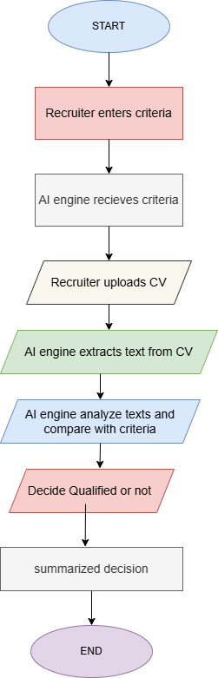

***Figure 3.2 System flow chat of new system***

# **CHAPTER FOUR: SYSTEM IMPLEMENTATION, TESTING, RESULTS AND DOCUMENTATION**

## 4.1 System Implementation

The implementation of the AI-powered recruitment chatbot system called RecruitAI, involved setting up both the frontend and backend components, integrating third-party services, and ensuring smooth communication between all parts of the application. The system was designed to guide users through a step-by-step recruitment flow, beginning with the input of job criteria and followed by CV uploads for evaluation. The backend handled the core logic and AI integration, while the frontend provided a user-friendly chatbot interface using EJS and vanilla JavaScript. Cloud services such as DeepSeek were used for resume analysis, and Cloudinary handled secure file storage. The development process emphasized a modular and scalable architecture, ensuring that each part of the system operates efficiently.

### 4.1.1 New System Requirements

The development and deployment of the AI-powered recruitment chatbot required a set of minimum hardware and software specifications to ensure efficiency and performance both requirements ae discussed below.

1. **Hardware Requirements**

The system was designed to run smoothly on a standard development machine with at least 4GB of RAM, although 8GB was preferable for a smoother experience. A processor equivalent to Intel Core i5 or higher was used for both frontend and backend development tasks, at least 200MB of free disk space was needed for local dependencies, and an internet connection was essential to interact with the external AI APIs such as deepseek, bcrypt amongst others and for file uploads to cloud storage.

1. **Software Requirements**

From the software perspective, the backend was built using Node.js and Express.js, which required installation of Node.js version 22. A non-relational database management system like MONGODB was used to store data such as user information, businesses, and uploaded CVs. Visual Studio Code served as the preferred development environment due to its simplicity and rich plugin support. Postman was used to test RESTful endpoints during development, while Cloudinary was used for managing CV file uploads. For interacting with the application, a modern web browser which includes chrome, safari, explorer etc can be used.

### ****4.1.2 Program Development****

The development of the AI-powered recruitment chatbot system was driven by the need for an efficient, and easily integrable technology stack. The system was designed with a focus on speed, seamless integration with external services, and leveraging existing AI models to automate and enhance the resume analysis process. A host of technolgies was used which combined to facilitate development and provided a foundation for future enhancements and feature additions.

1. **Choice of Programming Environment**

The programming environment for the system was chosen based on the system's requirements for ease of development and integration with third-party services. The backend was built using **Node.js**, which provides a non-blocking, event-driven architecture ideal for handling real-time communication with the chatbot. The system's frontend was developed using html, css along with **JavaScript** to maintain simplicity and flexibility. This approach was lightweight and efficient for a system that did not require a heavy frontend framework like React or Vue. **Express.js** was used for routing, ensuring an efficient API structure. Third-party services like **DeepSeek AI** for resume analysis and **Cloudinary** for file storage were seamlessly integrated. This combination of technologies ensured a smooth development process and a robust solution for the recruitment chatbot system.

1. **Language Justification**

The choice of JavaScript throughout the stack both on the client and server provided consistency, reduced the learning curve, and made development faster. MONGODB was used for database querying which suited the data model of the application.

## 4.2 Testing and Results

Testing was conducted to verify the functionality, accuracy, and reliability of the recruitment chatbot. The system was tested using several real-world recruitment scenarios involving different roles and criteria, such as developers with JavaScript experience or candidates with specific academic qualifications.

### 4.2.1 System Testing

System testing is a very important phase in development lifecycle it ensures that the system meets both functional and non-functional requirements. For this system, testing was conducted to validate the core features such as the user interaction flow, resume parsing, candidate evaluation, and file handling. The system underwent rigorous testing to confirm the accuracy of AI-driven responses, the reliability of the backend API, and the proper handling of various file formats. The testing process was iterative, with each new feature being validated and modified to meet user’s requirements.

**a. Test Plan**

The chatbot interaction flow was tested from start to finish. It began with the user being greeted and prompted to enter recruitment criteria. These criteria were processed and saved, after which the user was allowed to upload up to 10 CVs in PDF or DOCX formats. The CVs were uploaded to Cloudinary, converted to plain text, and passed to DeepSeek for analysis. The AI model then evaluated each CV against the structured criteria and returned a summary, a list of matched criteria, and a match score. Each component of the system was tested with relevant data. For example, CVs were tested against criteria that included experience level, required skills (like React, Node.js), and educational background. The chatbot correctly identified candidates who met at least 60% of the given criteria, labeling them as "Qualified" and others as "Not Qualified." The system also retained user steps through JWTs, allowing users to resume the process if interrupted.

**b. Test Data**

Test data used included sample resumes representing a variety of qualification levels, skills and projects. These resumes were designed to simulate real-life applicants applying for various roles. Test results showed that the system correctly analyzed and scored the resumes based on the selected criteria. Each resume was processed individually, and results were presented clearly in the chat interface.

1. ****Limitations of the System****

Despite its overall effectiveness, the system had a few limitations. It only accepted resumes in PDF and DOCX formats, which excluded scanned or image-based resumes, the AI parser was limited to English language resumes, and there was no OCR support. Since DeepSeek was used as an external API, any downtime or latency in the AI service would directly affect the system's ability to evaluate resumes.

### ****4.3 Results and Documentation****

The RecruitAI system has several features that were thoroughly tested and are documented below, with placeholders for the corresponding screenshots from the application to guide users on how the system works.

**User registration and Log in:** To keep track of user data and session to manage their steps, the system uses JSON Web Tokens (JWT) . Even if the user refreshes or returns later, RecruitAI resumes at the correct stage without requiring redundant input.

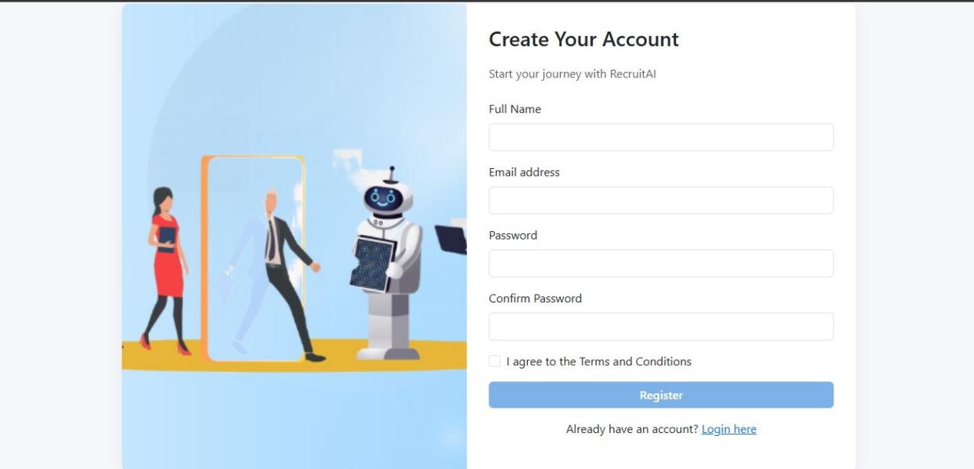

***Figure 4.1.1 Registration***

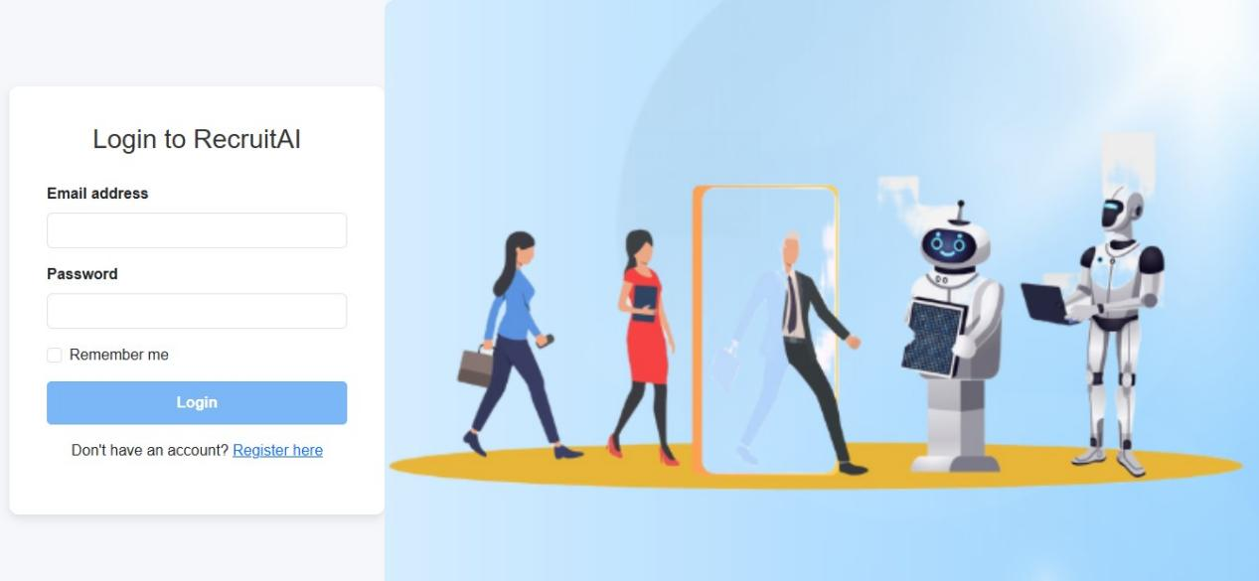

***Figure 4.1.2 Log in***

**Chatbot Interaction:** The core of RecruitAI is its real-time chatbot interface, which guides users through each step of the recruitment flow. Upon loading, the chatbot greets the user and prompts them to enter their recruitment criteria in natural language. This conversational approach makes it easy for non-technical users to interact with the system.

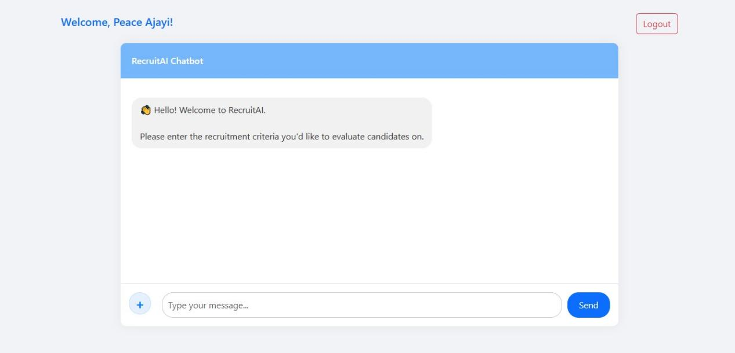

***Figure 4.2 Welcome message***

**Criteria Interpretation:** After the user submits their criteria, the bot confirms receipt and prompt user to upload their Cvs.

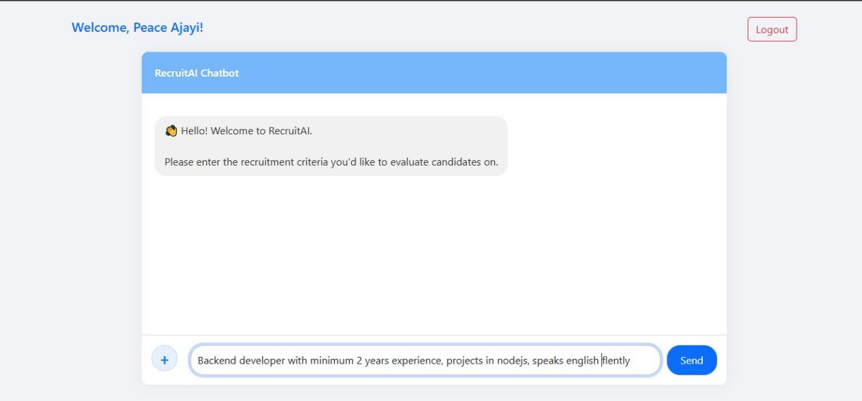

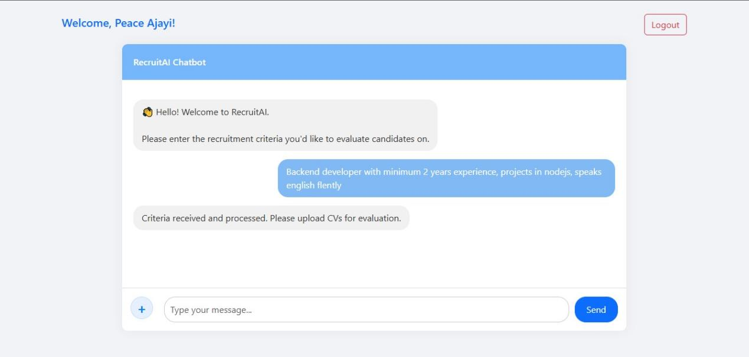

***Figure 4.3 criteria input***

**Multi‑CV Upload Interface:** Next, the chatbot transitions to the CV upload stage, allowing users to select and upload up to ten resumes at once in PDF or DOCX format. The upload widget shows each file’s name and upload status in real time, ensuring clarity around which documents have been received.

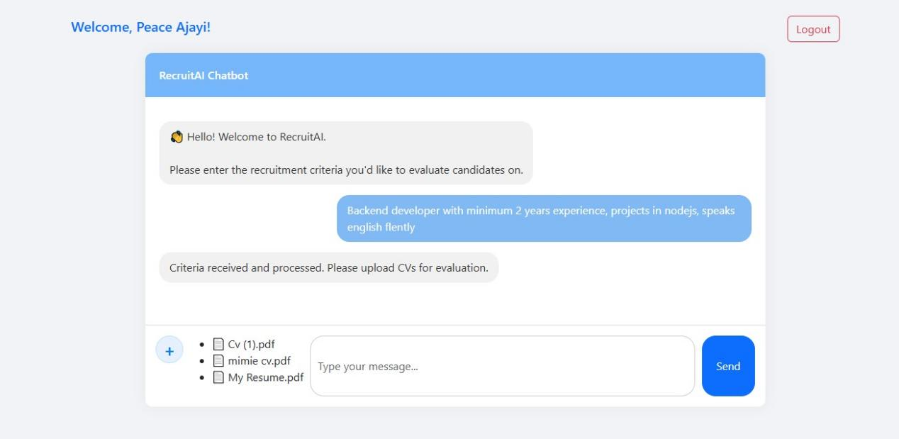

***Figure 4.3 CV upload***

**AI‑Driven Resume Parsing:** Each uploaded resume is sent to a serivce that extracts structured information such as candidate name, contact details, list of skills, years of experience, and educational background which is then given to the DeepSeek AI that does the analysis.

**Scoring and Qualification Algorithm:** RecruitAI applies a scoring algorithm that compares the parsed resume data against the user’s criteria. A match percentage is calculated, and candidates who meet at least 60% of the requirements are labeled “Qualified.” The evaluation summary shows both matched and missing criteria, giving users clear insight into each candidate’s strengths and gaps.

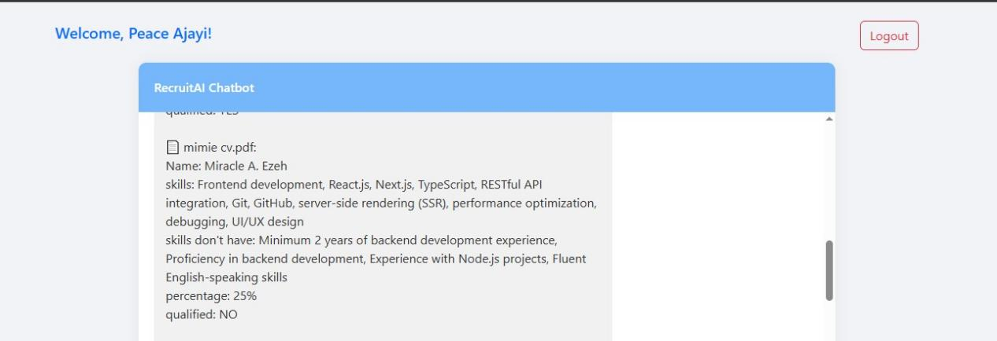

***Figure 4.3.1 CV analysis (not-qualified)***

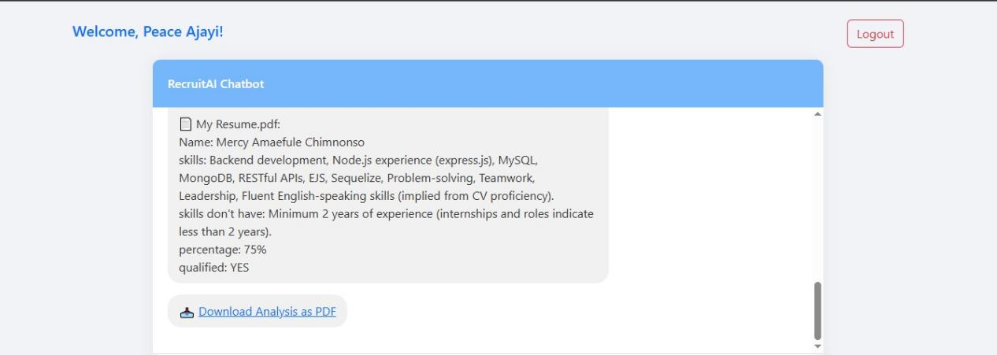

***Figure 4.3.2 CV analysis (qualified)***

After the analysis to help recruiters keep record of the CV analysis done a download link is provided.

At the end **RecruitAI** successfully integrates a user‑friendly chat interface, robust multi‑file handling, advanced AI parsing, and a clear scoring mechanism to automate the initial recruitment screening process.

# **CHAPTER FIVE****: SUMMARY, CONCLUSION AND RECOMMENDATION**

* 1. **Summary**

This project focused on the design and implementation of RecruitAI, an AI-powered recruitment screening and management chatbot system. The objective was to streamline the initial stages of recruitment by leveraging artificial intelligence to interpret job criteria, evaluate multiple resumes, and generate candidate qualification summaries. The system was built using a Node.js backend, HTML and CSS for the frontend, and integrated an external AI service (DeepSeek) to handle resume parsing and analysis.

Key functionalities of the system included:

1. Real-time chatbot interaction
2. Input of natural language recruitment criteria
3. Multi-file CV upload with support for PDF and DOCX formats
4. AI-driven resume parsing and summary generation
5. A match-scoring algorithm based on a 60% threshold
6. Session tracking via JWT for continuity in user interaction

The development process emphasized simplicity, usability, and responsiveness while ensuring technical consistency across the stack. Each component of the system was tested to validate its functionality, and screenshots were taken to document both the user interface and backend logic flow.

## Conclusion

The development of RecruitAI an AI-powered recruitment screening and management chatbot has shown just how helpful AI-powered tools can be in making recruitment processes smoother and more reliable. By letting the chatbot handle the initial stage of screening, checking resumes against specific criteria, it takes a huge load off HR teams and speeds up the process, instead of manually going through dozens or even hundreds of applications, recruiters can now rely on the chatbot to provide quick, consistent, and unbiased results. What makes RecruitAI stand out is how easy it is to use. It guides the user through each step, from entering the job criteria to uploading CVs, and then uses AI to break down each resume, compare it with the requirements, and return clear results. The chatbot also ensures everyone follows the same process, so all candidates are evaluated fairly using the same format, removing any inconsistencies or bias in the process. Through the integration of advanced AI models and modern web technologies such as Node.js, HTML, CSS, and JWT, RecruitAI achieves both functionality and reliability, delivering clear summaries and match scores for each applicant. RecruitAI shows just how far we can go when we combine AI with user-friendly design, and it points to a future where smarter, faster, and fairer hiring becomes the norm.

## Recommendation

Based on the development and performance of the system, I recommended that organizations seeking to automate their recruitment process adopt AI-driven tools such as this. RecruitAI’s ability to evaluate multiple resumes against custom criteria and provide summarized qualification insights makes it a valuable asset, especially during high-volume hiring. One of its key strengths is its enforcement of a uniform evaluation format, which eliminates discrepancies in human judgment and ensures that all candidates are assessed fairly and consistently. Its simple interface, resume parsing capability, and scoring mechanism present a reliable and scalable foundation for digital recruitment systems.

### Application Areas

The RecruitAI system can be applied in a variety of environments, particularly where efficient and objective resume screening is essential. These areas include:

1. Human Resource Departments of companies and startups to pre-screen candidates before interviews.
2. Recruitment Agencies that handle applications across multiple organizations or roles.
3. Job Portals to provide instant feedback to applicants based on uploaded resumes.
4. Educational Institutions for screening students applying for internships or placement programs.
5. Freelancing Platforms to match candidate profiles with project requirements.

### Suggestions for Further Research

While the system RecruitAI meets its primary goals, further research could expand the system’s capabilities and improve its efficiency. Potential directions include:

1. Machine Learning Integration for continuous learning based on hiring outcomes and feedback loops.
2. Ranking and Recommendation Systems to not just qualify candidates, but also prioritize top matches.
3. Voice Interaction Capability to enhance accessibility and allow voice-based input for job descriptions or chatbot interaction.
4. Integration with Applicant Tracking Systems (ATS) and popular HR tools for seamless workflow.

These areas would help refine the accuracy and intelligence of the system, making it more adaptive and robust for broader recruitment use cases.

# REFERENCES

Albassam, W. A. (2023). The power of artificial intelligence in recruitment: An analytical review of current AI-based recruitment strategies. International Journal of Professional Business Review, 8(6), e02089. [https://doi.org/10.26668/businessreview/2023.v8i6.2089](https://doi.org/10.26668/businessreview/2023.v8i6.2089" \t "_new)

Dixit, S., Sharma, N., Maurya, M., & Dharwal, M. (2022). AI power: Making recruitment smarter. In Choudhury, A., Singh, T. P., Biswas, A., & Anand, M. (Eds.), Evolution of digitized societies through advanced technologies (pp. 251–270). Springer. [https://doi.org/10.1007/978-981-19-2984-7\_14](https://doi.org/10.1007/978-981-19-2984-7_14" \t "_new)

Haley, L. (2023). The European Union's proposed artificial intelligence regulation on recruiting and hiring processes. Scitech Lawyer, 19(3), 26–30.

Alrakhawi, H. A. S., Elqassas, R., Elsobeihi, M. M., Habil, B., Abunasser, B. S., & Abu-Naser, S. S. (2024). Transforming Human Resource Management: The Impact of Artificial Intelligence on Recruitment and Beyond. International Journal of Academic Information Systems Research (IJAISR), 8(8), 1-5.

Ali, I., Mughal, N., Khand, Z. H., Ahmed, J., & Mujtaba, G. (2022). Resume classification system using natural language processing and machine learning techniques. Mehran University Research Journal Of Engineering & Technology, 41(1), 65–79. [https://search.informit.org/doi/10.3316/informit.263278216314684](https://search.informit.org/doi/10.3316/informit.263278216314684" \t "_new)

Saatci, M., Kaya, R., & Ünlü, R. (2024). Resume Screening With Natural Language Processing (NLP). Alphanumeric Journal, 12(2), 121-140. [https://doi.org/10.17093/alphanumeric.1536577](https://doi.org/10.17093/alphanumeric.1536577" \t "_new)

Sinha, A.K., Amir Khusru Akhtar, M., Kumar, A. (2021). Resume Screening Using Natural Language Processing and Machine Learning: A Systematic Review. In: Swain, D., Pattnaik, P.K., Athawale, T. (eds) Machine Learning and Information Processing. Advances in Intelligent Systems and Computing, vol 1311. Springer, Singapore. [https://doi.org/10.1007/978-981-33-4859-2\_21](https://doi.org/10.1007/978-981-33-4859-2_21" \t "_new)

Köchling, A., Wehner, M.C. & Warkocz, J. Can I show my skills? Affective responses to artificial intelligence in the recruitment process. *Rev Manag Sci* 17, 2109–2138 (2023). <https://doi.org/10.1007/s11846-021-00514-4>

Hunkenschroer, A.L., & Kriebitz, A. (2023). Is AI recruiting (un)ethical? A human rights perspective on the use of AI for hiring. AI Ethics, 3, 199–213. https://doi.org/10.1007/s43681-022-00166-4

European Union AI Act. (2023). Regulation of the European Parliament and of the Council laying down harmonized rules on artificial intelligence. European Commission.

Tippins, Nancy T.; Oswald, Frederick L.; and McPhail, S. Morton (2021) "Scientific, Legal, and Ethical Concerns About AI-Based Personnel Selection Tools: A Call to Action, Personnel Assessment and Decisions: Number 7 : Iss. 2 , Article 1 https://doi.org/10.25035/pad.2021.02.001

Equal Employment Opportunity Commission (EEOC). (2023). Guidance on the use of artificial intelligence in employment decision-making. U.S. EEOC.

FraiJ, J., & László, V. (2021). A literature review: Artificial intelligence impact on the recruitment process. International Journal of Engineering and Management Sciences, 6(1), 108-119. https://doi.org/10.21791/IJEMS.2021.1.10

Ore, O., & Sposato, M. (2022). Opportunities and risks of artificial intelligence in recruitment and selection. International Journal of Organizational Analysis. https://doi.org/10.1108/IJOA-06-2021-2809

Tuffaha, M. ., Pandya, B. ., & Perello-Marin, M. R. . (2022). AI-powered chatbots in recruitment from Indian HR professionals’ perspectives: Qualitative study. *The Journal of Contemporary Issues in Business and Government*, *28*(4), 1971–1989. Retrieved from <https://cibgp.com/au/index.php/1323-6903/article/view/2737>

Ali, I., Mughal, N., Khand, Z. H., Ahmed, J., & Mujtaba, G. (2022). Resume classification system using natural language processing and machine learning techniques. Mehran University Research Journal Of Engineering & Technology, 41(1), 65–79. <https://search.informit.org/doi/10.3316/informit.263278216314684>

A. Hemalatha, P. B. Kumari, N. Nawaz and V. Gajenderan, "Impact of Artificial Intelligence on Recruitment and Selection of Information Technology Companies," 2021 International Conference on Artificial Intelligence and Smart Systems (ICAIS), Coimbatore, India, 2021, pp. 60-66, doi: 10.1109/ICAIS50930.2021.9396036. keywords: {Automation;Machine vision;Urban areas;Transforms;Natural language processing;Artificial intelligence;Recruitment;Artificial intelligence;Natural Language Processing;machine vision;Automation;augmentation;Human resource management practices;Recruitment & Selection.},

Alrakhawi, Hazem A. S. ; Elqassas, Randa ; Elsobeihi, Mohammed M. ; Habil, Basel ; Abunasser, Basem S. & Abu-Naser, Samy S. (2024). Transforming Human Resource Management: The Impact of Artificial Intelligence on Recruitment and Beyond. International Journal of Academic Information Systems Research (IJAISR) 8 (8):1-5.

DDI Development. (2023). [Benefits of AI in recruiting according to recruiterss] [Image]. AI-powered ATS: Revolutionizing the Hiring Process. DDI Development.https://ddi-dev.com/blog/programming/ai-applicant-tracking-system-revolutionizing-the-hiring-process/